Data Aggregation Activity – Module 5

Phil Roth

C0776168

It seems like the HR simulation is broken, and it will not accept my input. Here are the HDInsight cluster queries which I created, giving me the desired results. Please consider these aggregate queries as my submission for this evaluation.

Since the aggregation activity is carrying on with the transformed dataset from Assignment 4, there are a number of steps occurring before the Step #1 below. (MonthlyIncome rounded to 1000, filtered to show only the 'Sales' Dept, sorted by JobSatisfaction)

**Step #1**

CREATE TABLE sales_attrition_transf

(

Attrition string,

MonthlyIncome int

);

INSERT OVERWRITE TABLE sales_attrition_transf

SELECT Attrition, MonthlyIncome

FROM employee_sales;

*I have named the new column as "attrition_count", as the database already has a column named "attrition"*

SELECT COUNT(attrition) AS attrition_count

FROM sales_attrition_transf

WHERE attrition LIKE "%Yes%";

CREATE TABLE sales_non_attrition_transf

(

Attrition string,

MonthlyIncome int

);

INSERT OVERWRITE TABLE sales_non_attrition_transf

SELECT Attrition, MonthlyIncome

FROM employee_sales;

*I have named the new column as "non_attrition_count", as the database already has a column named "non_attrition"*

SELECT COUNT(attrition) AS non_attrition_count

FROM sales_non_attrition_transf

WHERE attrition LIKE "%No%";

**Step #2**

CREATE TABLE sales_stats_transf

(

Attrition string,

MonthlyIncome int

);

INSERT OVERWRITE TABLE sales_stats_transf

SELECT Attrition, MonthlyIncome

FROM employee_sales;

SELECT AVG(MonthlyIncome) AS average_monthly_income, MIN(MonthlyIncome) AS min_monthly_income, MAX(MonthlyIncome) AS max_monthly_income

FROM sales_stats_transf;

SELECT AVG(MonthlyIncome) AS average_monthly_income, MIN(MonthlyIncome) AS min_monthly_income, MAX(MonthlyIncome) AS max_monthly_income

FROM sales_stats_transf

WHERE attrition LIKE "%Yes%";

SELECT AVG(MonthlyIncome) AS average_monthly_income, MIN(MonthlyIncome) AS min_monthly_income, MAX(MonthlyIncome) AS max_monthly_income

FROM sales_stats_transf

WHERE attrition LIKE "%No%";

**Step #3**

SELECT MonthlyIncome, COUNT(MonthlyIncome) AS Count

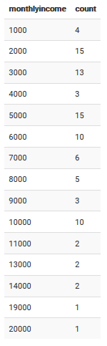FROM sales_stats_transf

WHERE attrition LIKE "%Yes%"

GROUP BY MonthlyIncome;

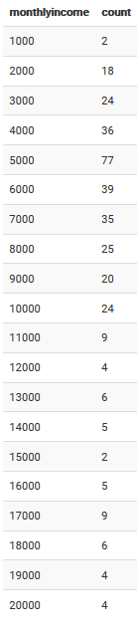SELECT MonthlyIncome, COUNT(MonthlyIncome) AS Count

FROM sales_stats_transf

WHERE attrition LIKE "%No%"

GROUP BY MonthlyIncome;